**Application**

**Office Staff use only**

Date received: Time:

|  |  |  |
| --- | --- | --- |
| **Last Name First Name Middle Initial** | | **Primary Phone Number:**  **( )**  **Consent to use this number** |
| **Street Address City/State Zip Code** | | **In mass text messaging**  **EZ Texting**  |
| **In case of emergency**  **notify:**  **Relationship:** | **Emergency contact number(s):**  **( )**  **( )** | |

|  |
| --- |
| To be eligible, you must be an enrolled member of the Mississippi Band of Choctaw Indians.  **Tribal Enrollment Number:___________________________________** |

|  |
| --- |
| Have you ever been convicted of a felony or misdemeanor other than a minor traffic offense which has not been expunged or sealed by a court? Yes No  **If yes, list the date, city, charge and disposition: ________________________________ ____ ____**  **__________________________________________________________________________________ ___________** |

|  |  |  |  |  |  |  |  |  |  |  |  |  |  |  |  |  |  |  |  |  |  |
| --- | --- | --- | --- | --- | --- | --- | --- | --- | --- | --- | --- | --- | --- | --- | --- | --- | --- | --- | --- | --- | --- |
| **List any work experience or abilities:**  **1.**  **2.**  **3.**  **List any Certificates or Awards:**  **1.**  **2.**  **3.** | |  |  |  |  | | --- | --- | --- | --- | | **Rate your language reading and writing skills.**  **Place a check mark in following box.** | | | | | **Languages** | **Fluent** | **Good** | **Fair** | | Choctaw |  |  |  | | English |  |  |  | | Specify any other language spoken: | | | | |

|  |  |  |  |
| --- | --- | --- | --- |
| **Name of High school attended:** | **City/State** | **Graduate?** | **GED?** |
| **Name of College attended:** | **City/State** | **Graduate or Degree completed?** | **Number of years in college?**  1 3  2 4 |

|  |  |
| --- | --- |
| **Are you currently employed?**  **Yes**______ **No**_______  **If No, Name of Last Employment** ­­____________________________________________  __________________________________________________________________________________________________________________ | **Is Applicant receiving any other type of Income**?  **Yes** _________ **No** _________  **If yes, please name the following source of Income received?** _________________________________________________________________________________________ |

|  |
| --- |
| Please describe or list any ***disabilitie*s** or ***limitations*** that you may have. This will help provide the program information concerning yours needs in finding placement: **___________________________________________________________________________________________________________________________________________** |

|  |
| --- |
| **CAREFULLY READ EACH STATEMENT BEFORE SIGNING AT THE BOTTOM** |
| I certify that all of the information provided in this application is true and complete to the best of my knowledge and I authorize investigation of all statements contained in this application, including a criminal background, as applicable. I understand that any false or incomplete information may disqualify me from further consideration and may result in my immediate dismissal if discovered at a later date.  I authorize the investigation of any of all statements contained in this application and also authorize any person, school, past employers, and other organizations to provide information concerning my previous employment and other relevant information that may be useful in making a hiring decision. I release such persons and organizations from any legal liability in making such statements.  I have read, understand, and agree to the above statements.  ***Signature***: ­­­­­­­­­­­­­­­­­­­­­________________________________________________________________________________________________­­­­­­  ***Date***: ______________________________________ |

|  |  |
| --- | --- |
| **BACKGROUND INVESTIGATION AUTHORIZATION/ DISCLOSURE** | |
| I authorize and instruct all corporations, companies, educational institutions, persons, law enforcement agencies, Workers’ Compensation agencies, criminal, civil, and federal courts, and former employers to release information they have about me  and release them from any liability and responsibility from doing so. Any copy of this authorization shall have the same authority as the original.  ***Signature***: ­­­­­­­­­­­­­­­­­­­­­__________________________________________________________________________________________________***Date***: ______________________________________ | |
| Required information (Please print clearly) | |
| **Name (First, MI, Last)** | **Maiden or other Name** |
| **Social Security Number** | **Date of Birth** |
| **Driver License Number and State** | |

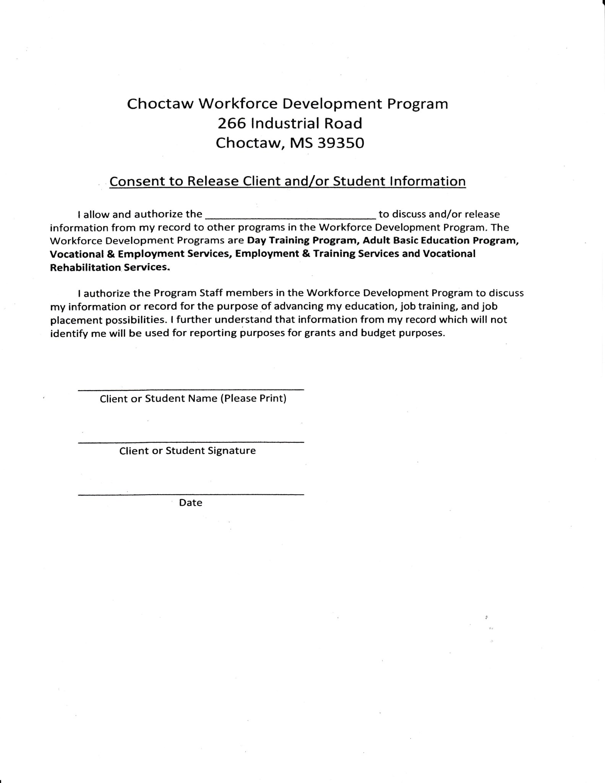

Day Training Program